**Install Power BI Desktop and share the final screenshot of the report view page which appears when power desktop starts.**

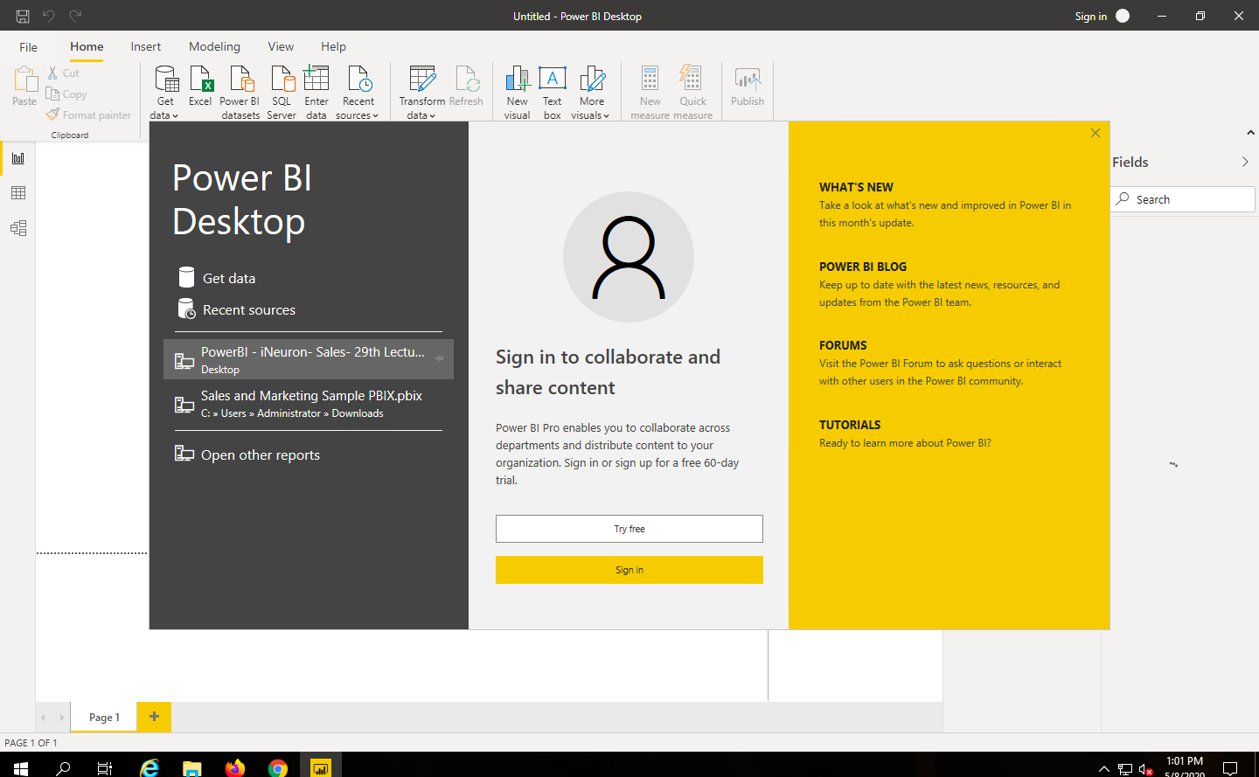

**Prepare a document and with the following screenshot**

**− Report View**

**− Data View**

**− Model View**

**− Power Query Editor**

**− Advance Editor**

***Report View***

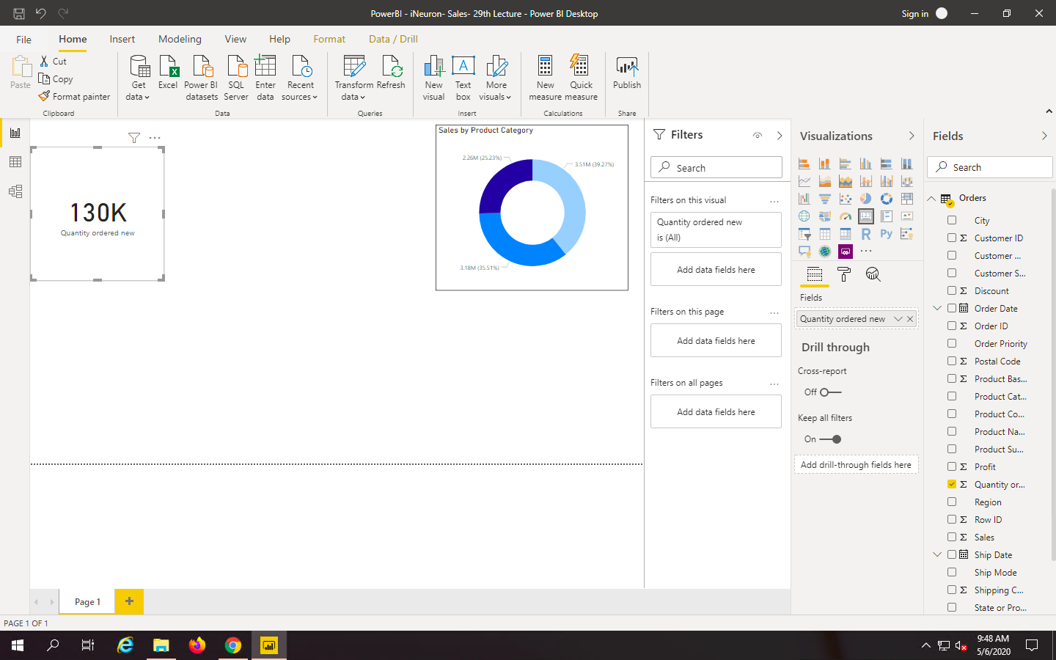

***Data View***

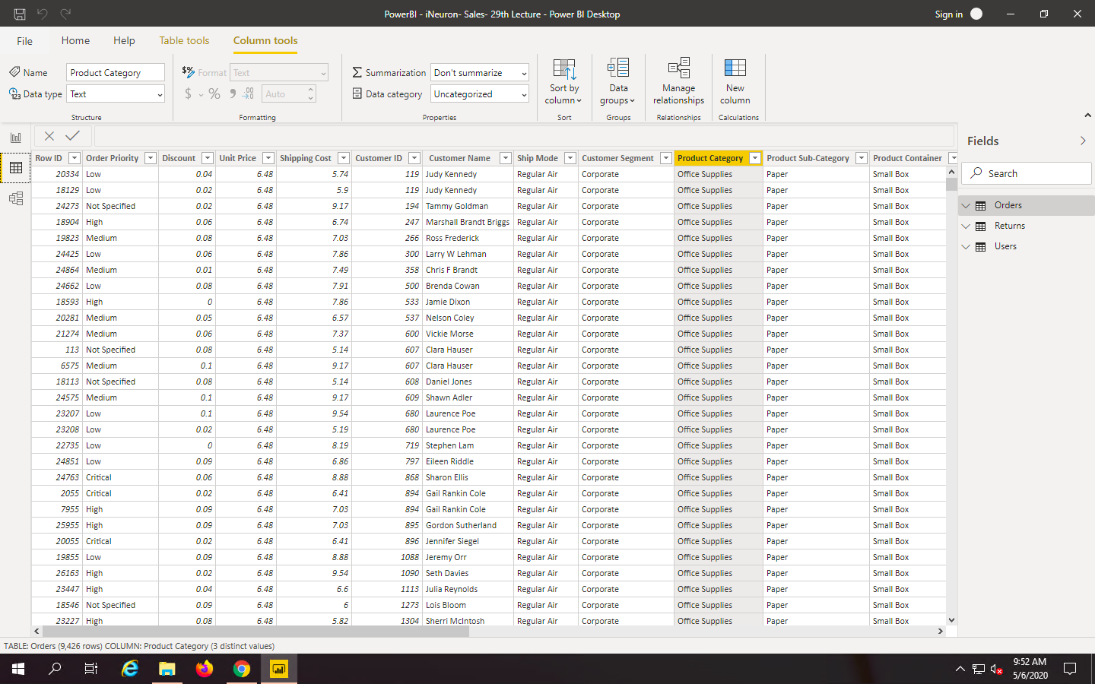

***Model View***

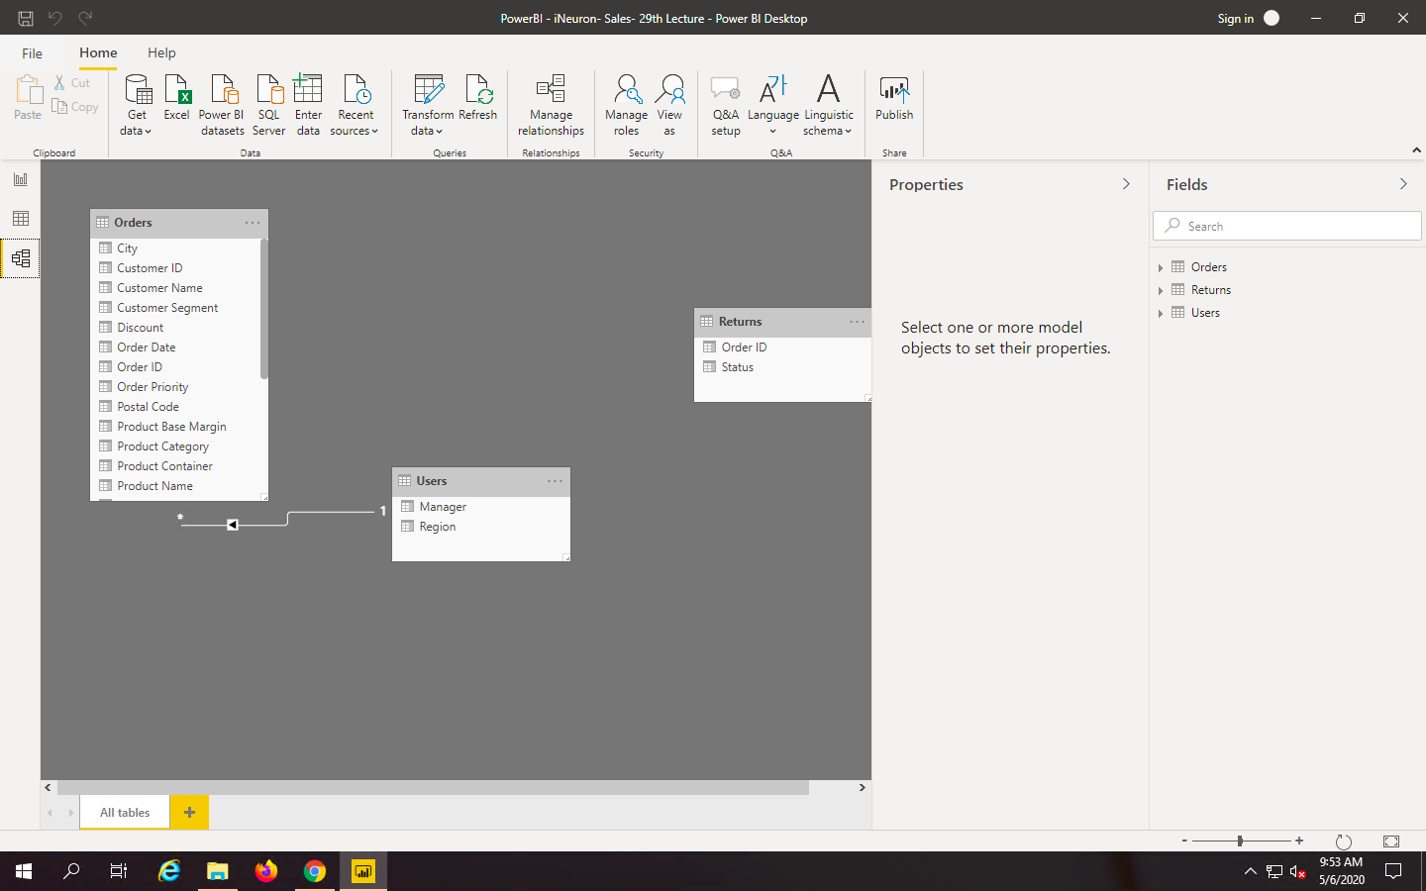

***Power Query Editor***

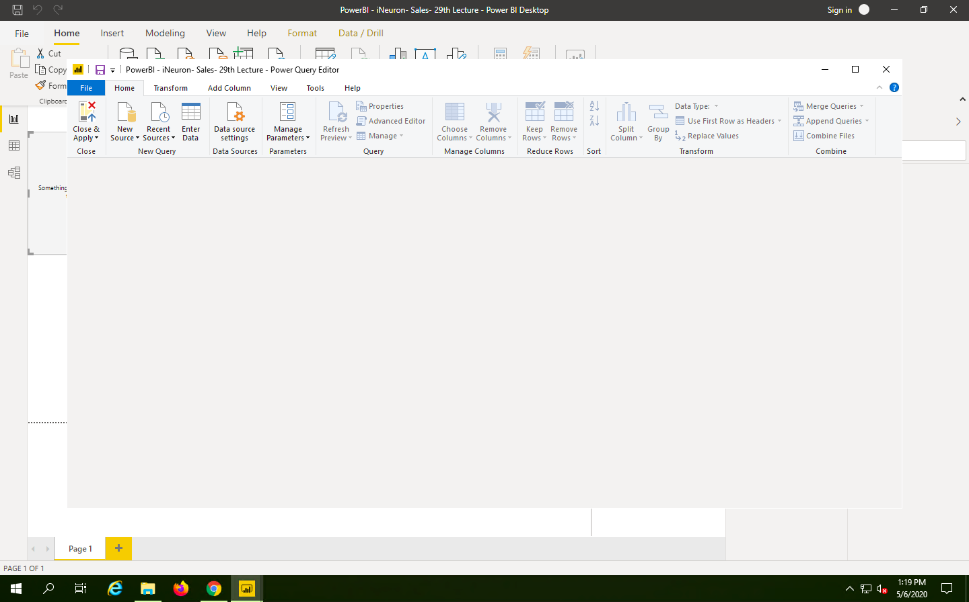

***Advance Editor***

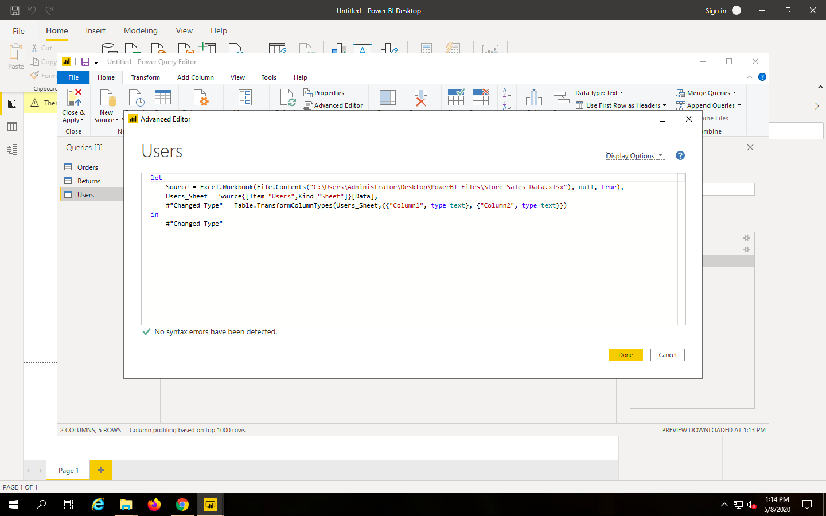

Prepare a document with details of the following along with their price

− Power BI Desktop

− Power BI Pro

− Power BI Premium

s